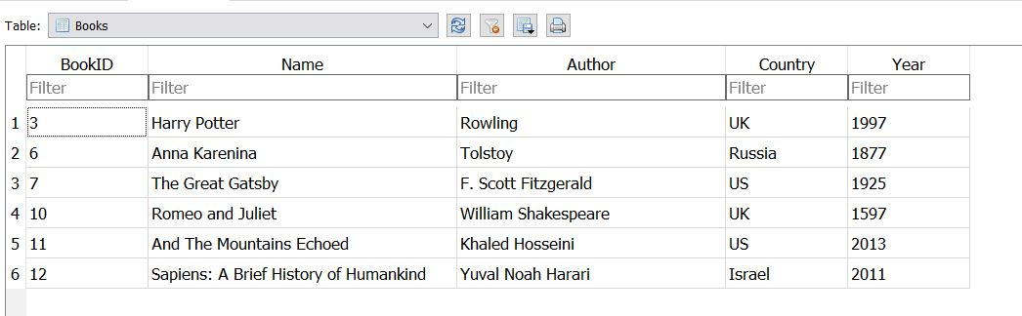

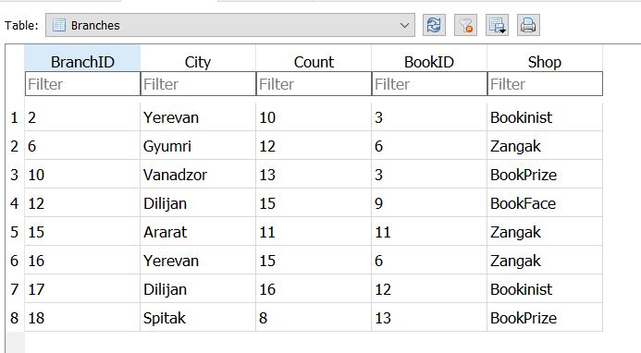

**1.Count in how many branches exists book with 3 ID**

**SELECT count(BranchID)**

**FROM Branches**

**WHERE BookID=3**

**2.Return the names and cities of all the books from Zangak store**

**SELECT Name,City**

**FROM Books**

**INNER JOIN Branches**

**ON Books.BookID=Braches.BookID**

**WHERE Shop='Zangak'**

**3. Count the Sum of books, return sum and name of books**

**SELECT sum(Count),Name**

**FROM Branches**

**INNER JOIN Books**

**ON Branches.BookID=Books.BookID**

**GROUP BY Name**

**4. Return all books name and authors those count between 11 and 15**

**SELECT Name,Author**

**FROM Books**

**INNER JOIN Branches**

**ON Books.BookID=Braches.BookID**

**WHERE count BETWEEN 11 and 15**

**5.Return books names and counts, those are not exists in Yerevan**

**SELECT Name,Country**

**FROM Books**

**INNER JOIN Branches**

**ON Books.BookID=Braches.BookID**

**WHERE City !=** **'Yerevan'**

**6. Using subquery select the city of the “And the mountains Echoed Book**

**SELECT City FROM Branches where BookID=(SELECT BookId FROM Books WHERE Name=’And the mountains Echoed’)**